MWE Arduino Project

Humidity and temperature measurement

Humidity and temperature are common parameters to measure environmental conditions. In this Arduino based project we are going to measure ambient temperature and humidity and display it on a 16x2 LCD screen. A combined temperature and himidity sensor DHT11 is used with Arduino uno to develop this Celsius scale thermometer and percentage scale humidity measurement project. In one of my previous project, I have also developed a [digital thermometer](http://circuitdigest.com/microcontroller-projects/digital-thermometer-using-arduino) using temperature sensor LM35.

This project consists of three sections - one senses the humidity and temperature by using **humidity and temperature sensor DHT11**. The second section reads the DHTsensor module’s output and extracts temperature and humidity values into a suitable number in percentage and Celsius scale. And the third part of the system displays humidity and temperature on LCD.

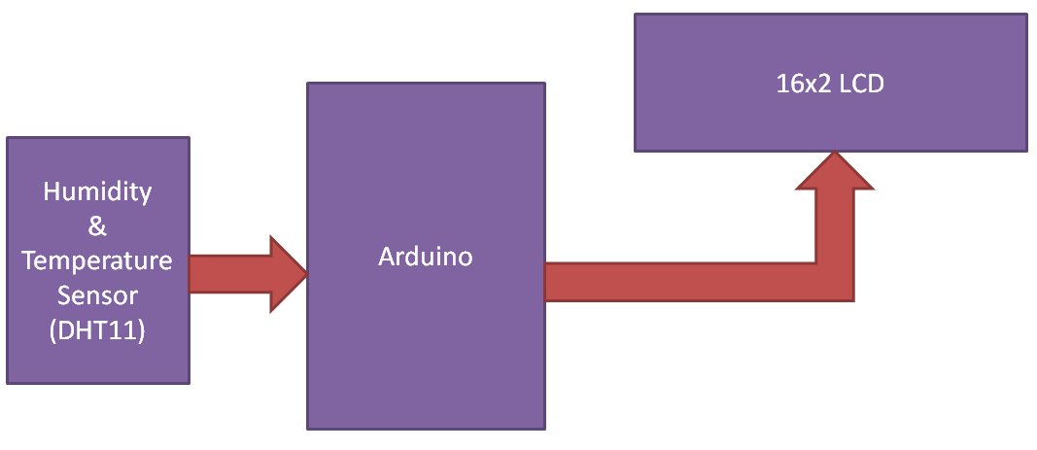

Working of this project is based on single wire serial communication. First arduino send a start signal to DHT module and then DHT gives a response signal containing temperature and humidity data. Arduino collect and extract in two parts one is humidity and second is temperature and then send them to 16x2 LCD.

Here in this project we have used a sensor module namely **DHT11**. This module features a humidity and temperature complex with a calibrated digital signal output means DHT11 sensor module is a combined module for sensing humidity and temperature which gives a calibrated digital output signal. DHT11 gives us very precise value of humidity and temperature and ensures high reliability and long term stability. This sensor has a resistive type humidity measurement component and NTC type temperature measurement component with an 8-bit microcontroller inbuilt which has a fast response and cost effective and available in 4-pin single row package.

DHT11 module works on serial communication i.e. single wire communication. This module sends data in form of pulse train of specific time period. Before sending data to arduino it needs some initialize command with a time delay. And the whole process time is about 4ms. A complete data transmission is of 40-bit and data format of this process is given below:

8-bit integral RH data + 8-bit decimal RH data + 8-bit integral T data + 8-bit decimal T data + 8-bit check sum.

**Complete Process**

First of all arduino sends a high to low start signal to DHT11 with 18µs delay to ensure DHT’s detection. And then arduino pull-up the data line and wait for 20-40µs for DHT’s response. Once DHT detects starts signal, it will send a low voltage level response signal to arduino of time delay about 80µs. And then DHT controller pull up the data line and keeps it for 80µs for DHT’s arranging of sending data.

When data bus is at low voltage level it means that DHT11 is sending response signal. Once it is done, DHT again makes data line pull-up for 80µs for preparing data transmission.

Data format that is sending by DHT to arduino for every bit begins with 50µs low voltage level and length of high voltage level signal determines whether data bit is “0” or “1”.

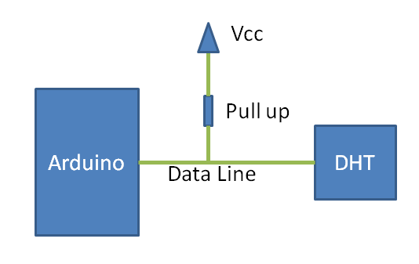

Circuit Diagram and Explanation

[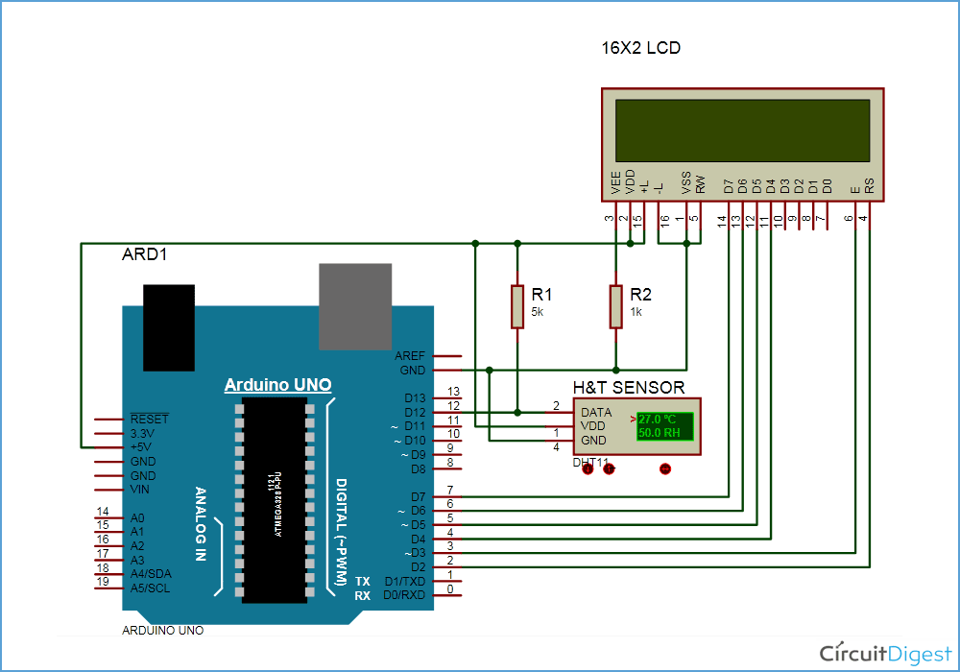](https://circuitdigest.com/fullimage?i=circuitdiagram_mic/Arduino-Humidity-Circuit.gif)

A liquid crystal display is used for displaying temperature and humidity which is directly connected to arduino in 4-bit mode. Pins of LCD namely RS, EN, D4, D5, D6 and D7 are connected to arduino digital pin number 2, 3, 4, 5, 6 and 7. And a DHT11 sensor module is also connected to digital pin 12 of arduino with a 5k pull-up resistor.

Programming Description

In programming, we are going to use pre-built libraries for DHT11 sensor and LCD display module.

Header file

Then we haved defined pins for LCD and DHT sensor and initialized all the things in setup. Then in a loop by using dht function reads DHT sensor and then using some dht functions we extract humidity and temperature and display them on LCD.

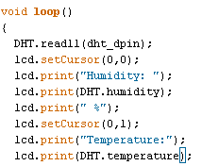

Here degree symbol is created by using custom character method.

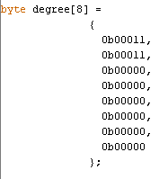

**Code:**

#include<dht.h>      // Including library for dht  
#include<LiquidCrystal.h>  
LiquidCrystal lcd(2, 3, 4, 5, 6, 7);

#define dht_dpin 12

dht DHT;

byte degree[8] =   
              {  
                0b00011,  
                0b00011,  
                0b00000,  
                0b00000,  
                0b00000,  
                0b00000,  
                0b00000,  
                0b00000  
              };

void setup()  
{  
 lcd.begin(16, 2);  
 lcd.createChar(1, degree);  
 lcd.clear();  
 lcd.print("   Humidity   ");  
 lcd.setCursor(0,1);  
 lcd.print("  Measurement ");  
 delay(2000);  
 lcd.clear();  
 lcd.print("Circuit Digest ");  
 delay(2000);  
}

void loop()  
{  
  DHT.read11(dht_dpin);  
  lcd.setCursor(0,0);  
  lcd.print("Humidity: ");  
  lcd.print(DHT.humidity);   // printing Humidity on LCD  
  lcd.print(" %");  
  lcd.setCursor(0,1);  
  lcd.print("Temperature:");  
  lcd.print(DHT.temperature);   // Printing temperature on LCD  
  lcd.write(1);  
  lcd.print("C");  
  delay(500);  
}